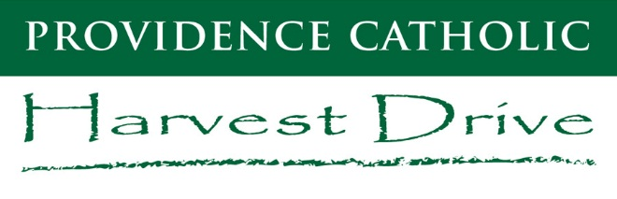 | Money Turn-In Form

Use the form below to list the number of raffle tickets and the amount of money that you are turning in today for the Harvest Drive. This form should ONLY be used when making a “return” on the designated Money Turn-In Days. There is also a section below to include any checks/cash for patrons who purchased an E-Directory ad listing and provided you with the ad contract and money. Please include the ad contract with this form and place in your student envelope.

IMPORTANT: DO NOT LIST ANY MONEY THAT WAS RECEIVED ONLINE, THRU THE MAIL OR MONEY THAT YOU ANTICIPATE RECEIVING. LIST ONLY MONEY (CASH/CHECKS) THAT YOU HAVE IN YOUR POSSESSION TODAY! CHECKS PREFERABLE!

Today’s Date:
Student Name: |  |  |  |  |  | Class year:
Student ID # (if known): |  |  |  |  |  | PCHS Siblings? | Yes | No
List PCHS Siblings (if applicable):

RAFFLE TICKET SALES | EXAMPLE | TOTAL
What is the Total Number of Raffle Tickets you are turning in today? | 15 | TICKETS
What is the Total Amount of Money that you are turning in for raffle tickets today? | $150.00 | $

Do you have an ad contract and money for an E-Directory advertisement listing? If so, use the space below to write/type the patron’s name/business, check # (if applicable) and the total dollar amount of the ad(s). Place an “X” under the appropriate ad level (Platinum, Gold, Bronze) and if the patron paid with cash.
E-DIRECTORY AD LISTING (PATRON NAME/BUSINESS) | $500  PLATINUM | $300  GOLD | $100  BRONZE | CASH | CHECK # | TOTAL $
1.
2.
3.
4.
5.
 |  |  |  |  | AD TOTAL $: | $

 | GRAND TOTAL $
Combine the Total Amount of cash/checks that you are turning in today (include money from ad listings (if applicable) and raffle ticket sales). | $

