E-Directory Advertisement Contract
By completing the contract below, you are allowing Providence Catholic High School to publish your listing via the Harvest Drive E-Directory on the school’s website. This form should only be completed if you are submitting this contract and payment via U.S. mail.

SELECT GIVING LEVEL* | Platinum ($500) |  | Gold ($300) | Bronze ($100) |  | * Mandatory Fields

BUSINESS/INDIVIDUAL CONTACT INFORMATION

Business Name Sort Name (see below) No Business

Note: The "Sort Name" will help to ensure your ad is listed in alphabetical order under your selected category. For example: The Home Depot's "Sort Name" should be entered as "Home Depot, The" so the listing is sorted by "H" rather than "T".

Contact’s First Name
*

Contact's Last Name
*

Address
*

City
*

State (IL)
*

Zip
*

Phone Number* (10 digits - numbers only) Email Address*

WHAT STUDENT SHOULD RECEIVE CREDIT FOR SELLING THIS ADVERTISEMENT?

Note: In cases of families with two or more students at PCHS, please list only one of the student's names. Credit will be divided equally.

(1) Student FIRST Name* (1) Student LAST Name* (1) Student ID #(if known)

IF APPLICABLE, ADD ADDITIONAL STUDENT CREDIT BELOW.

Note: Limited to a total of four students/families. Credit will be divided equally.

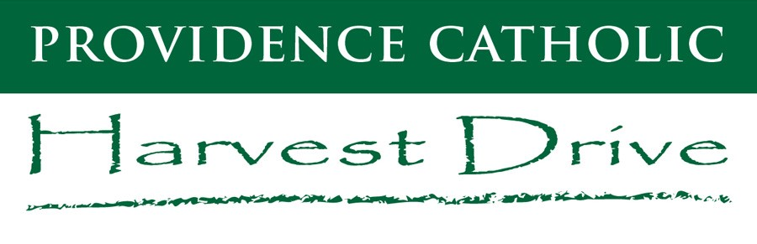
No Additional Student Credit

(2)
Student FIRST
Name

(2)
Student LAST
Name

(
2
)
Student ID #
(
if known
)

(3) Student FIRST Name (3) Student LAST Name (3) Student ID #(if known)

(4) Student FIRST Name | (4) Student LAST Name | (4) Student ID #(if known)
WHAT CATEGORY BEST DESCRIBES YOUR ADVERTISEMENT?* TYPE/WRITE THE CATEGORY BELOW.

Note: Use "Family Ad" for Non-Business related ads that express well wishes to a student.

HOW WILL YOU PAY FOR YOUR AD?*

Paypal/online Check
Note: If paying by check, please include a copy of this ad contract and mail payment to the address listed below. No cash please.

Print this completed contract. Save a copy for your records. Mail the contract and payment to the address listed above.
QUESTIONS? CONTACT SHANNON WITHERS, HARVEST DRIVE COORDINATOR
VISIT THE HARVEST DRIVE WEB PAGE ● EMAIL HARVESTDRIVE@PROVIDENCECATHOLIC.ORG ● CALL 815-717-3160

