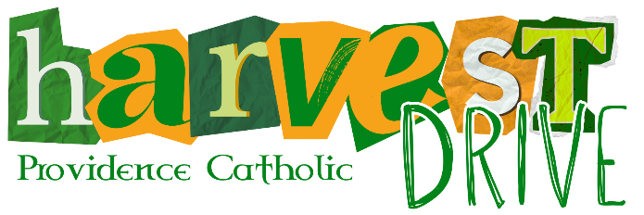
E-Directory Advertisement Contract
By completing the contract below, you are allowing Providence Catholic High School to publish your listing via the Harvest Drive E-Directory on the school’s website. This form should only be completed if you are submitting this contract and payment via U.S. mail or in person. Otherwise, all add contract and payment should be made online.

SELECT GIVING LEVEL* | Platinum ($500) |  | Gold ($300) | Bronze ($100) |  | * Mandatory Fields

BUSINESS/INDIVIDUAL CONTACT INFORMATION

Business Name Sort Name (see below) No Business

Note: The "Sort Name" will help to ensure your ad is listed in alphabetical order under your selected category. For example: The Home Depot's "Sort Name" should be entered as "Home Depot, The" so the listing is sorted by "H" rather than "T".

Contact’s First Name
*

Contact's Last Name
*

Address
*

City
*

State (IL)
*

Zip
*

Phone Number* (10 digits - numbers only) Email Address*

WHAT STUDENT SHOULD RECEIVE CREDIT FOR SELLING THIS ADVERTISEMENT?

Note: In cases of families with two or more students at PCHS, please list only one of the student's names. Credit will be divided equally.

(1) Student FIRST Name* (1) Student LAST Name* (1) Student ID #(if known)

IF APPLICABLE, ADD ADDITIONAL STUDENT CREDIT BELOW.

Note: Limited to a total of four students/families. Credit will be divided equally.

No Additional Student Credit

(2)
Student FIRST
Name

(2)
Student LAST
Name

(
2
)
Student ID #
(
if known
)

(3) Student FIRST Name (3) Student LAST Name (3) Student ID #(if known)

