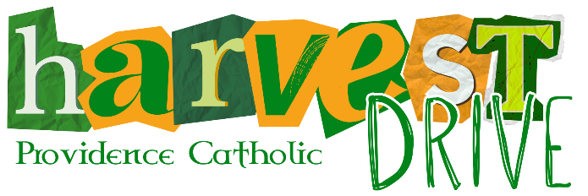
Student/Family Prize Incentives
Students/Families that surpass their Harvest Drive quota by at least $100 are entitled to receive tuition credit or a gift card to Starbucks, Target, or the PCHS Spirit Shop. Below are two charts; one for individual students and one for families with two or more students attending Providence Catholic. All money must be turned in by 9 a.m. on Wednesday, September 17 (NO EXCEPTIONS) to be applied toward the student/family’s “Total Return”. Students/Families who are eligible to claim a prize will be emailed a Prize Selection Form on Monday, November 3. Gift card prizes will be distributed in early December. Tuition credit will be reflected on the December tuition statements.
  INDIVIDUAL STUDENT PRIZE INCENTIVES
  Total Return Range |  |  |  | Prize
  $ 500.00 | - | $ 599.00 |  | $10
  $ 600.00 | - | $ 699.00 |  | $20
  $ 700.00 | - | $ 799.00 |  | $30
  $ 800.00 | - | $ 899.00 |  | $60
  $ 900.00 | - | $ 999.00 |  | $75
  $ 1,000.00 | - | $ 1,099.00 |  | $90
  $ 1,100.00 | - | $ 1,199.00 |  | $105
  $ 1,200.00 | - | $ 1,299.00 |  | $125
  $ 1,300.00 | - | $ 1,399.00 |  | $140
  $ 1,400.00 | - | $ 1,499.00 |  | $200
  $ 1,500.00 | - | $ 1,599.00 |  | $220
  $ 1,600.00 | - | $ 1,699.00 |  | $245
  $ 1,700.00 | - | $ 1,799.00 |  | $265
  $ 1,800.00 | - | $ 1,899.00 |  | $285
  $ 1,900.00 | - | $ 1,999.00 |  | $305
  $ 2,000.00 | - | $ 2,099.00 |  | $325
  $ 2,100.00 | - | $ 2,199.00 |  | $345
  $ 2,200.00 | - | $ 2,299.00 |  | $365
  $ 2,300.00 | - | $ 2,399.00 |  | $385
  $ 2,400.00 | - | $ 2,499.00 |  | $405
  $ 2,500.00 | - | $ 2,599.00 |  | $425
  $ 2,600.00 | - | $ 2,699.00 |  | $445
  $ 2,700.00 | - | $ 2,799.00 |  | $465
  $ 2,800.00 | - | $ 2,999.00 |  | $485
  $ 3,000.00 | - | or more |  | $500
  FAMILY PRIZE INCENTIVES
  Total Return Range |  |  |  | Prize
  $ 700.00 | - | $ 799.00 |  | $10
  $ 800.00 | - | $ 899.00 |  | $20
  $ 900.00 | - | $ 999.00 |  | $30
  $ 1,000.00 | - | $ 1,099.00 |  | $60
  $ 1,100.00 | - | $ 1,199.00 |  | $75
  $ 1,200.00 | - | $ 1,299.00 |  | $90
  $ 1,300.00 | - | $ 1,399.00 |  | $105
  $ 1,400.00 | - | $ 1,499.00 |  | $125
  $ 1,500.00 | - | $ 1,599.00 |  | $140
  $ 1,600.00 | - | $ 1,699.00 |  | $200
  $ 1,700.00 | - | $ 1,799.00 |  | $220
  $ 1,800.00 | - | $ 1,899.00 |  | $245
  $ 1,900.00 | - | $ 1,999.00 |  | $265
  $ 2,000.00 | - | $ 2,099.00 |  | $285
  $ 2,100.00 | - | $ 2,199.00 |  | $305
  $ 2,200.00 | - | $ 2,299.00 |  | $325
  $ 2,300.00 | - | $ 2,399.00 |  | $345
  $ 2,400.00 | - | $ 2,499.00 |  | $365
  $ 2,500.00 | - | $ 2,599.00 |  | $385
  $ 2,600.00 | - | $ 2,699.00 |  | $405
  $ 2,700.00 | - | $ 2,799.00 |  | $425
  $ 2,800.00 | - | $ 2,899.00 |  | $445
  $ 2,900.00 | - | $ 2,999.00 |  | $465
  $ 3,000.00 | - | or more |  | $500

QUESTIONS? CONTACT SHANNON WITHERS, HARVEST DRIVE COORDINATOR
VISIT THE HARVEST DRIVE WEB PAGE ● EMAIL HARVESTDRIVE@PROVIDENCECATHOLIC.ORG ● CALL 815-717-3160

