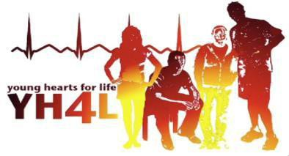
February 10, 2021

Dear Parents,
Unfortunately, Covid-19 has not slowed down the need for us to continue our mission in preventing another senseless death in our youth. It is more important now than ever to make screening available to young adults. YH4L has worked closely with infectious disease specialists to create a safe environment for your child as well as our volunteers.

We are pleased to bring the Young Hearts for Life® (YH4L) Cardiac Screening Program to Providence Catholic High School on March 4th and 5th, 2021. All students whose parents authorize them to be tested will be screened. Please be aware that repeat ECG testing is recommended every two (2) years.

YH4L will provide this Free heart screening called an electrocardiogram (ECG) to identify high school students at risk for sudden cardiac death and to increase the public's awareness of this issue. To date over 260,000 students have been screened as a result of YH4L. More information about the screening can be found on the YH4L website (www.yh4l.org).

A simple ECG, when used to screen young adults can detect certain serious heart conditions. Recording the electrical activity of the heart using electrodes attached to the skin with a mild adhesive, can detect approximately 70% of the abnormalities or “markers” from these heart conditions that are associated with sudden cardiac death that a stethoscope cannot. Please note that ECG screenings result in less than 2% of the tests being falsely positive. This may require additional evaluation and testing by your physician. We believe that the benefit of this potentially lifesaving screening outweighs this concern.

We encourage you to discuss this screening with your child. Your child’s participation in the screening is your decision. We want to assure you that students’ confidentiality, privacy and individual modesty will be respected throughout all aspects of the program. Only female technicians will test girls and they will be screened in an area separate from boys.

The Young Hearts For Life® Cardiac Screening is being provided to your students by YH4L Donors, EKGs for EGK and the Brian Peck YH4L Memorial Fund. To learn more about other programs offered by YH4L and to register your child for this lifesaving screening, please visit our website at http://www.yh4l.org/. If you have questions, please contact us at 630-785-4366.
Sincerely,
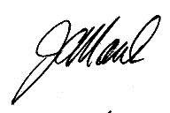
Joseph Marek, MD
Founder & Medical Director, Young Hearts for Life® Cardiac Screening Program
Cardiologist, Advocate Medical Group

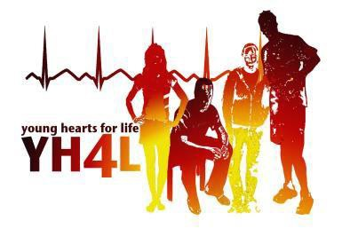

Young Hearts for Life
The Young Hearts for Life (YH4L) Cardiac Screening Program identifies high school and college students at risk for sudden cardiac death. Each week sudden cardiac death claims the lives of more than 60 young adults in the United States.

Cardiovascular disease is the leading cause of death in the United States and in Illinois. YH4L, under the guidance of Dr. Joseph Marek, a clinical cardiologist, seeks to detect young adults at risk for sudden cardiac death, and increase community awareness of this devastating problem. YH4L does this by providing FREE ECGs that can identify those heart conditions that can cause sudden death.

A number of cardiac conditions can result in sudden death. An electrocardiogram (ECG) can detect certain impulse patterns or “markers” associated with these conditions that a stethoscope cannot. HCM (hypertrophic cardiomyopathy), WPW (Wolff-Parkinson-White Syndrome), Long QT Syndrome, ARVD (arrhythmogenic right ventricular dysplasia) and Brugada Syndrome are the most common cardiac conditions causing sudden death that can be detected by ECG.

In 2004, the International Olympic Committee and the European Society of Cardiology recommended that athletes under the age of 35 be screened with an ECG every 2 years before participation in sports. Medical experts in the U.S. have not adopted the European recommendations for ECG testing, as a result there are no routine screening programs for these conditions in the U.S.

YH4L, by working with area high schools and colleges, offers ECG testing to all students free-of- charge. To date, over 260,000 students have been screened and hundreds of young adults have been identified with previously unsuspected, life threatening, cardiac conditions.

Screening consists of a quick, simple, painless ECG. Volunteers attach electrodes to the students’ chest and limbs in preparation for the ECG. The ECG machine monitors the electrical activity of the heart and prints out the information about heart rate and rhythm. A trained cardiologist then interprets the printed ECG. The false abnormal rate for our program is less than 2%. This rate is better than the false abnormal rate for most other screenings in healthcare.

For more information, visit our website at www.YH4L.org Young Hearts for life is a 501C3 tax exempt organization.

“…. To save one life, is as if you have saved the world.”

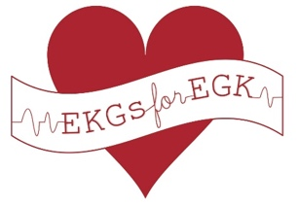
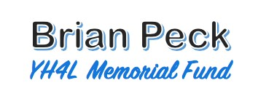

Providence Catholic High School
Free ECG Screening
March 4th and 5th, 2021
TO REGISTER YOUR CHILD FOR THIS FREE SCREENING:

Please go to www.YH4L.org
- Hover on Registration and Events
- Click Registration and Results
- Select Chicago/Chicago Suburbs
- Click on the permission button to access the Registration Page
You will need your student’s School ID number to register.
TO REGISTER AS A VOLUNTEER:
Thank you for your interest in helping us provide ECG screenings to the students at Providence Catholic HS on March 4th and 5th, 2021.
All volunteers must attend one of the training sessions held on Wednesday, March 3rd, and choose a day and shift to volunteer at.
We're using SignUp.com for volunteer sign up for our event with Young Hearts for Life.
- Click this link to go to our invitation page on SignUp.com: https://signup.com/go/MGBTRvH
- Enter your email address: (You will NOT need to create an account on SignUp.com)
- Sign up! Be sure to sign up for your training session AND your volunteer shift the day of the screening.
SignUp.com will send you an automated confirmation and reminders
Thank you!
If you have any questions, please contact:
*For more information about YH4L, please visit our website, www.YH4L.org.
**Sign up is available now online**

