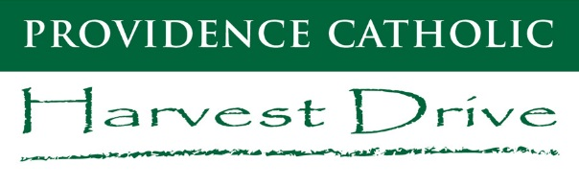 | Special Bell Schedule

OLYMPICS & RAFFLE DRAWING
Friday, September 13

Zero Hour 7:25 - 7:50
Period 1 7:55 - 8:20
Period 2 8:25 - 8:50
Prayer 8:50 - 8:55
Period 3 9:00 - 9:25
Period 4 9:30 - 9:55
Period 5 10:00 - 10:25
Period 6 10:30 - 10:55
Period 7 11:00 - 11:25
Period 7 (lunch) 11:25 – 12:35
Olympics 12:35
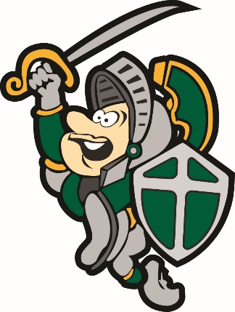
        - Top Student/Family Prizes
        - Raffle Drawing
Dismissal 2:35

After attending periods 1-7, students will remain in their 7th period class for lunch and prepare for the Harvest Drive Olympics. The Advancement Office will provide lunch, which will include two slices of Cheese Pizza and a beverage.
Friday, September 13th is a Dress Down Day for students who wear their class color!
SENIORS ‘20  BLACK |  | JUNIORS ‘21  GREEN |  | SOPHOMORES ‘22  WHITE |  | FRESHMEN ‘23  YELLOW

